**A notification and shutdown system for water pumps**

**using Internet of Things (IoT) technology.**

**Thammanit Nooyimsai* Chayut Sapphakhao Tanapon Songrak and Thapanawat Chooklin**

Princess Chulabhorn Science High School Nakhon Si Thammarat pipenahni@gmail.com

Abstract

This project is to create a notification and auto shut down system for water pumps using Internet of Things (IoT) technology. Main objective is to prevent damage caused by irregular operating conditions such as dry run or excessive energy consumption. The system has a flow switch to monitor water flow and a PZEM-004T sensor to measure current. Data from these components are processed by the NodeMCU ESP8266 microcontroller which will display the data on LCD screen and through Blynk Legacy app. Users will receive real time notification via Telegram Notify service.

The experiment is to program the ESP8266 to monitor sensor data, detect anomaly and control the relay module to cut off power to the pump when necessary. Result show that the system can detect abnormal condition and respond fast by sending notification and safely shut down the pump. Also it provide user with easy to use interface to adjust parameters such as flow delay, current limit and shutdown procedure.

In summary the system achieve its goal of safety, cost saving and water usage efficiency. Suitable for residential, agricultural and industrial use. Future improvement can be added such as cloud based data logging and support multiple pump system.

**Keywords :** Notification, Water pump, Shutdown system, Internet of Things

1. Introduction

Water pumps are used in daily life, especially in households, agriculture, government agencies and private organizations. These pumps run continuously. But a common problem is when the pump is running but not delivering any water, a situation known as "Dry Run". This can damage the pump and waste electricity. From our experience in our village, we found that this problem happens often, that’s why we decided to study and solve the problem through this science project.

Dry Run problems have been discussed in many studies and research papers. For example Ittichai Rodkwan, Pongkana Mahasawat and Watcharin Krainara (2019) developed an automatic irrigation system for salacca plantation using IoT. Their system can monitor soil moisture and control water pumps through Blynk app and send alert via Line Notify. This can reduce equipment damage and improve efficiency. If this problem is not solve it can cause expensive repair and even electrical fire. With the advancement of Internet of Things (IoT) technology we can now monitor and control device remotely.It can auto shut down in abnormal condition, save energy and reduce maintenance cost.

This project is to develop a system to detect pump issues like Dry Run and auto shut down the pump. The system will also send real-time notification to user and record usage data for future reference. We hope this will prevent pump damage and make water usage safer and more efficient.

1. Literature Review

A study by Ittichai Rodkwan, Pongkana Mahasawat and Watcharin Krainara (2019) created an automatic online system for controlling watering in Salacca plantations. They used soil moisture sensors, an Arduino Mega 2560 and Blynk for remote control. The system can automatically irrigate based on soil data and notify the user via Line Notify when an anomaly occurs. This is related to our project’s focus on real-time monitoring and alerting to prevent Dry Run in water pumps [1].

One of the challenge in pump operation is detecting abnormal electrical consumption which can indicate Dry Run condition. In our project, this issue is solved using PZEM-004T power monitoring sensor. This sensor provide real-time power reading without manual calculation. The sensor automatically calculate the real power consumption, voltage, current and power factor which all processed by the system. If the power reading deviate significantly from the expected range, it can indicate that the pump is running without water or encounter electrical problem. This data is crucial to trigger the auto shutdown of the pump through NodeMCU ESP8266 and relay module.

IoT play major role in automation and communication. Blynk Legacy app provide graphical interface for user to monitor and adjust system setting via smartphone, while Telegram Notify send real time alert to user [4]. A similar approach was used by Siriwan Joranan, Thidarat Kongsawat and Nonthawat Chansan (2021) in their IoT system for controlling environmental condition in Budgerigar breeding which include alert notification and remote monitoring [2].

Based on literature review, it is clear that IoT-based monitoring system is effective in detecting anomaly, reduce system damage and improve overall efficiency. These study confirm the feasibility of integrating flow sensor, power monitoring module and alert system into one platform for water pump protection. This background support the direction and design of this science project.

1. **Methodology**

To fix Dry Run in water pumps, the team created an IoT-based system. This system can detect issues with water flow and electrical current, send real-time alerts, and shut down the pump when necessary. The process has four stages: research and planning, system design, system implementation, testing, and evaluation.

1. Research and Planning

The team began by studying the theory and components of centrifugal water pumps, Flow Switch sensors, PZEM-004T power sensors, and NodeMCU ESP8266 microcontrollers. They reviewed previous research and case studies to develop a system that fits real-world conditions.

2. System Design

The design phase included hardware and software elements.

* The Flow Switch detects if water flows through the pipe.
* The PZEM-004T measures the electrical current used by the pump.
* The NodeMCU ESP8266 receives sensor data, processes the logic, and controls the Relay Module to shut down the pump when necessary.

Notifications are sent through Telegram Notify, and the system status appears on Blynk Legacy and an LCD screen [6].

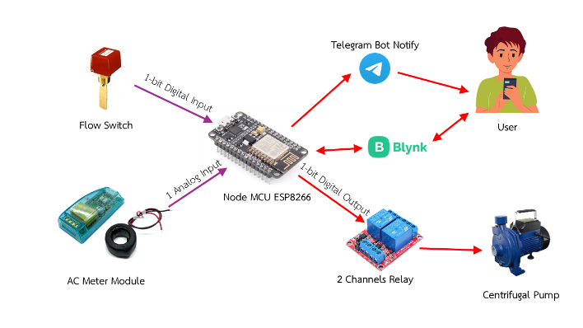

Figure 1 Hardware System Architecture

3. System Implementation

Components were assembled inside a plastic control box. Flow Switch was connected to water pipe outlet and relay module was wired to control the pump’s power. System was programmed using Arduino IDE and NodeMCU was connected to WiFi for Telegram and Blynk functionality.

Conditions Set

* FD (Flow Delay): If no water is detected for a user defined duration (e.g. 5 seconds) the system will send alert and shut down the pump.
* AD (Amp Delay): If current exceeds threshold (e.g. 5A) for more than 3 seconds the system will shut down.
* AMP Limit: User defined maximum current (e.g. 5A).
* Protect Mode: If ON the system will auto shut down.

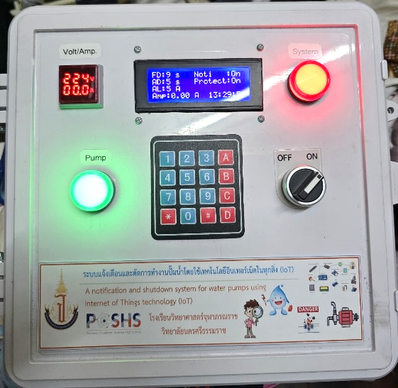

Figure 2 Front View of the Device

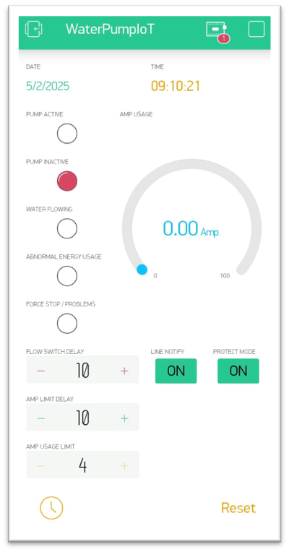

Figure 3 User Interface in Blynk Application

4. Testing and Evaluation

Multiple test cases were done

Normal Operation: Pump runs with proper flow and acceptable current.

Dry Run Simulation: Water source disconnected → no flow detected → system shut down after FD delay.

Overcurrent Simulation: Artificial load added to pump → current exceeded AMP limit → system shut down after AD delay.

Each test confirmed that the system responded correctly to abnormal conditions and sent real time alerts and auto shut down reliably.

Figure 4 Telegram Bot for System Notification Alerts

1. Results and Discussion

**Table 1 :** Pump Monitoring System Test

|  |  |  |  |
| --- | --- | --- | --- |
| **Test Case** | **Description** | **Expected** | **Results** |
| Normal Operation | Pump operates with water flow and normal current. | Pump should run without interruptions. | Pump operated normally. |
| Dry Run Simulation | Simulated by making the water flow through a different path for 10 seconds. | System should shut down water pump after 10 seconds. | 10/10 (100%)  Pump shut down. |
| Overcurrent Simulation | Simulated by Reduced Amp Limit and increase more electrical devices. | System should shut down water pump after exceeding Amp Limit for 5 seconds. | 10/10 (100%)  Pump shut down. |
| Protect Mode (ON) | Testing with Protect Mode enabled. | Pump should automatically shut down on any issue. | 10/10 (100%)  Pump shut down automatically. |
| Protect Mode (OFF) | Testing with Protect Mode disabled. | Pump should continue running even in fault conditions. | 10/10 (100%)  Pump continued running. |
| Telegram Notification Test | System sends Telegram alerts for abnormal operations. | Notification should be sent in real time. | 10/10 (100%)  Notification sent successfully. |

**Table 2 :** Touch Pad 4x4 and LCD Display Test

|  |  |  |
| --- | --- | --- |
| **Test Case** | **Description** | **Results** |
| Flow Delay Adjustment  (Buttons 1, 4) | Use touch pad buttons 1 and 4 to adjust Flow Delay (increase or decrease by 1 s). | 10/10 (100%)  Adjusted successfully. |
| Amp Delay Adjustment  (Buttons 2, 5) | Use touch pad buttons 2 and 5 to adjust Amp Delay (increase or decrease by 1 s). | 10/10 (100%)  Adjusted successfully. |
| Amp Limit Adjustment  (Buttons 3, 6) | Use touch pad buttons 3 and 6 to adjust Amp Limit (increase or decrease by 1 A). | 10/10 (100%)  Adjusted successfully. |
| Notify Toggle  (Button *) | Use touch pad button * to toggle Notify. | 10/10 (100%)  Toggled successfully. |
| Protect Mode Toggle  (Button #) | Use touch pad button # to toggle Protect Mode. | 10/10 (100%)  Toggled successfully. |
| System Reset  (Button 0) | Use touch pad button 0 to reset status of program. | 10/10 (100%)  Reset successfully. |
| LCD Display | LCD Display Time, Current Amp, FD, AD, AL, Notify, Protect Mode | Displayed correctly. |

**Table 3 :** Blynk App Control and Monitoring Test

|  |  |  |
| --- | --- | --- |
| **Test Case** | **Description** | **Results** |
| Time and Date Display | Blynk app displays the current Time and Date. | Time and date displayed correctly. |
| LED Indicators | The Blynk app shows 4 LED Status : **PUMP ACTIVE**, **PUMP INACTIVE**, **WATER FLOWING**, **ABNORMAL ENERGY USAGE**. | 10/10 (100%)  LED Displayed correctly. |
| Amp Usage Display | The Blynk app show the current **Amp usage** as a **gauge** in real time. | 10/10 (100%)  Amp usage gauge displayed correctly. |
| Flow Delay Adjustment | Use the Blynk app buttons to adjust Flow Delay (increase or decrease by 1 s). | 10/10 (100%)  Adjusted successfully. |
| Amp Delay Adjustment | Use the Blynk app buttons to adjust Amp Delay (increase or decrease by 1 s). | 10/10 (100%)  Adjusted successfully. |
| Amp Limit Adjustment | Use the Blynk app buttons to adjust Amp Limit (increase or decrease by 1 A). | 10/10 (100%)  Adjusted successfully. |
| Notify Toggle | Use Blynk app to toggle notifications. | 10/10 (100%)  Toggled successfully. |
| Protect Mode Toggle | Use Blynk app to toggle Protect Mode. | 10/10 (100%)  Toggled successfully. |
| System Reset | Use Blynk app to reset status of program. | 10/10 (100%)  Reset successfully. |

The results show it can detect Dry Run and overcurrent and shutdown the pump when needed. All 10 test cases passed. Every feature worked as expected and pump was shutdown after threshold. This is in line with Ittichai Rodkwan et al. (2019) which used IoT for automation and remote monitoring of irrigation system. But our system is different in dual monitoring of water flow and electrical current which is more comprehensive for pump protection. Also the integration of Telegram notifications and Blynk monitoring in our system allows user to receive real time alert and remotely control the pump which is more user friendly and controllable. One area for improvement is WiFi disconnection handling which can be improved by more advanced offline data logging or notification. Overall the system met its objective and provide a reliable and cost effective solution for water pump damage prevention, energy waste reduction and operational efficiency improvement.

1. Conclusion

In conclusion, the IoT based water pump monitoring and shutdown system solved the problem of Dry Run and overcurrent that causes pump damage and energy waste. The system can detect abnormal condition, shut down the pump and send real time notification to users. The experimental result which was consistent in all 10 test runs proved the system’s reliability and effectiveness in pump safety, maintenance cost and energy consumption. The integration of flow monitoring, power consumption tracking and remote notification through Telegram and Blynk is a complete solution for water pump management [4][5]. We can improve this system by adding offline data logging when WiFi is disconnected and expand to manage multiple pumps for bigger application in household and industrial. This project proves the potential of IoT in water pump management and a foundation for future innovation in automated system control and monitoring.

1. Acknowledgment

Thanks to many people and organizations for their help and support. Ms. Kusalin Thipmanosing, Computer Science teacher at Princess Chulabhorn Science High School Nakhon Si Thammarat and Mr. Thapanawat Chooklin, our project advisor for their guidance, motivation and support throughout the project especially for providing us with tools, resources and endless motivation.

We also would like to thank Mr. Wichai Ratchathani, the school director and all teachers and staff of Princess Chulabhorn Science High School Nakhon Si Thammarat for their continuous support and facilitation. Our thanks also go to our friends and peers who helped us from the very beginning.

Finally we would like to thank Electrical Engineering Academic Association (Thailand) and Electrical Engineering Society of Thailand for their advice and collaboration that made this article possible.

References

1. Ittichai Rodkwan, Pongkana Mahasawat and Watcharin Krainara. (2019). An automatic online system for the watering controls in Salacca plantations: A case study at the Salacca plantations of the community at Ban Nai Yang, Tambon Rommuang, Muang District, Patthalung Province. Department of Information Technology, Faculty of Science and Technology, Rajamangala University of Technology Srivijaya, Nakhon Si Thammarat Campus (Sai Yai). Retrieved May 30, 2024
2. Siriwan Joranan, Thidarat Kongsawat, & Nonthawat Chansan. (2021). An automatic online system for controlling Budgie breeding: A case study at Ban Nok Hong Yok Pak Phanang Farm in Pak Phanang District, Nakhon Si Thammarat Province. Department of Information Technology, Faculty of Science and Technology, Rajamangala University of Technology Srivijaya, Nakhon Si Thammarat Campus (Sai Yai). Retrieved May 30, 2024
3. Arduino IDE. (2021, November 18). *What is Arduino IDE?*. Retrieved May 30, 2024, from <https://www.ai-corporation.net/2021/11/18/what-is-arduino-ide/>
4. Telegram Notify. (n.d.). *How to send notifications via Telegram*. Retrieved May 30, 2024, from <https://pospos.co/article/detail/how%20to-Telegram-Notify>
5. Blynk. (n.d.). *Blynk IoT platform*. Retrieved May 30, 2024, from <https://blynk.io/>
6. LCD Display 20x4. (n.d.). *20x4 LCD Display for Arduino*. Retrieved May 30, 2024, from <https://www.ab.in.th/article/57/>

**Biography**

Thammanit Nooyimsai

Studying in 12th Grade Princess Chulabhorn Science High School Nakhon Si Thammarat.

Interested in DIY, Circuit, Coding , Computer engineer.

Chayut Sapphakhao

Studying in 12th Grade Princess Chulabhorn Science High School Nakhon Si Thammarat.

Interested in AI engineer, coding, computer engineer.

Tanapon Songrak

Studying in 12th Grade Princess Chulabhorn Science High School Nakhon Si Thammarat.

Interested in Circuit , Computer engineer.

Thapanawat Chooklin

Teaching in Computer and Technology department at Princess Chulabhorn Science High School Nakhon Si Thammarat.

Interested in Machine Learning, Data Science, Artificial Intelligence, Robotics and Automation System.